 P.O. Box 71, Moonee Vale 3055

**T** (03) 9384 2204

**F** (03) 9384 2205

**HURRY**

**UP AND**

**ENROL!**

**E** [lukebyles@kellysports.com.au](mailto:lukebyles@kellysports.com.au)

**SS PETER AND PAULS PRIMARY SCHOOL**

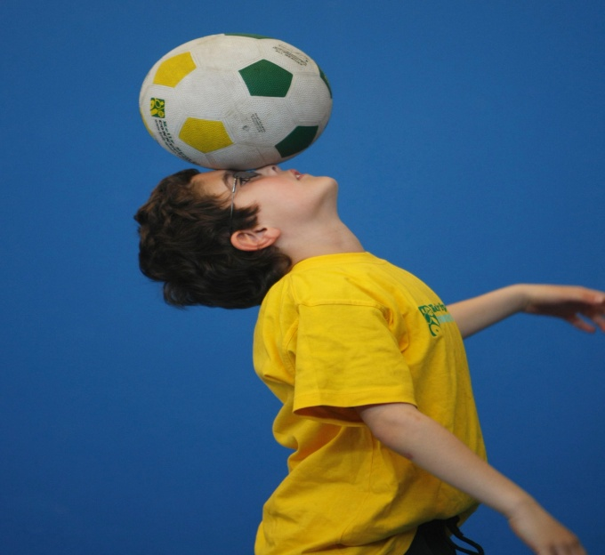

**WACKY WINTER SPORTS**

FOOTBALL - SOCCER - DODGEBALL – TURBO TOUCH   
This programme is a great way to challenge and improve your child’s motor skills and coordination within a FUN environment.  
We aim to develop and enhance ball skills, catching, kicking, throwing, co-operative skills and teamwork while improving strength, flexibility, hand-eye co-ordination and spatial awareness.

**WHEN:** Wednesday

**COMMENCING:** 16/7/14

**CONCLUDING:** 17/9/14

**TIME:** 3.40pm – 4.40pm

**YEAR LEVELS:** P – 4



**COST: $100**

**It’s here online enrolments !**

**To enrol**, please visit [www.kellysports.com.au](http://www.kellysports.com.au) or

fill out the enrolment form & **send** with a cheque or credit card details to:

Kelly Sports PO BOX 71, Moonee Vale, VIC, 3055.

Payment options available!

Do **not** leave enrolment forms at the school office

**VENUE: SS Peter and Pauls Primary School**

**­**

**It’s here online enrolments !**

**To enrol**, please visit [www.kellysports.com.au](http://www.kellysports.com.au) or

fill out the enrolment form & **send** with a cheque or credit card details to:

Kelly Sports PO BOX 71, Moonee Vale, VIC, 3055.

Payment options available!

Do **not** leave enrolment forms at the school office

**ONLINE ENROLMENT**

**www.kellysports.com.au**

To enrol, please visit **www.kellysports.com.au**

or fill out the below enrolment form & sendwith a cheque or

credit card details to: **PO BOX 71, Moonee Vale VIC 3055**.  
**Do not** leave enrolment forms at the school office.

**ENROLMENT FORM**

School: Year Level:

Name: Room No:

Address: Post Code:

Phone: Mobile/Work:

Email: Medical Conditions:

At the completion of after school clinics, does your child? □ Go to after care □ Get collected

**Parents’ consent: I hereby authorise Kelly Sports to act on my behalf should my child require medical attention, and release   
Kelly Sports Blackburn from any liability for injury incurred by my child at Kelly Sports programmes.**

Parent/Caregiver name: Signature:

Amount Paid: $ Credit card payment: □ **Visa** □ **Master card**

Card Number: □□□□ □□□□ □□□□ □□□□ Expiry Date: □□/□□

**It’s here online enrolments !**

**To enrol**, please visit [www.kellysports.com.au](http://www.kellysports.com.au) or

fill out the enrolment form & **send** with a cheque or credit card details to:

Kelly Sports PO BOX 71, Moonee Vale, VIC, 3055.

Payment options available!

Do **not** leave enrolment forms at the school office

**It’s here online enrolments !**

**To enrol**, please visit [www.kellysports.com.au](http://www.kellysports.com.au) or

fill out the enrolment form & **send** with a cheque or credit card details to:

Kelly Sports PO BOX 71, Moonee Vale, VIC, 3055.

Payment options available!

Do **not** leave enrolment forms at the school office

**It’s here online enrolments !**

**To enrol**, please visit [www.kellysports.com.au](http://www.kellysports.com.au) or

fill out the enrolment form & **send** with a cheque or credit card details to:

Kelly Sports PO BOX 71, Moonee Vale, VIC, 3055.

Payment options available!

Do **not** leave enrolment forms at the school office