 P.O. Box 3180, Joondalup, W.A. 6027

**T** 0438 833 746

**E** [davewhite@kellysports.com.au](mailto:davewhite@kellysports.com.au)

**MOTHER GOOSE EARLY LEARNING CENTRE**

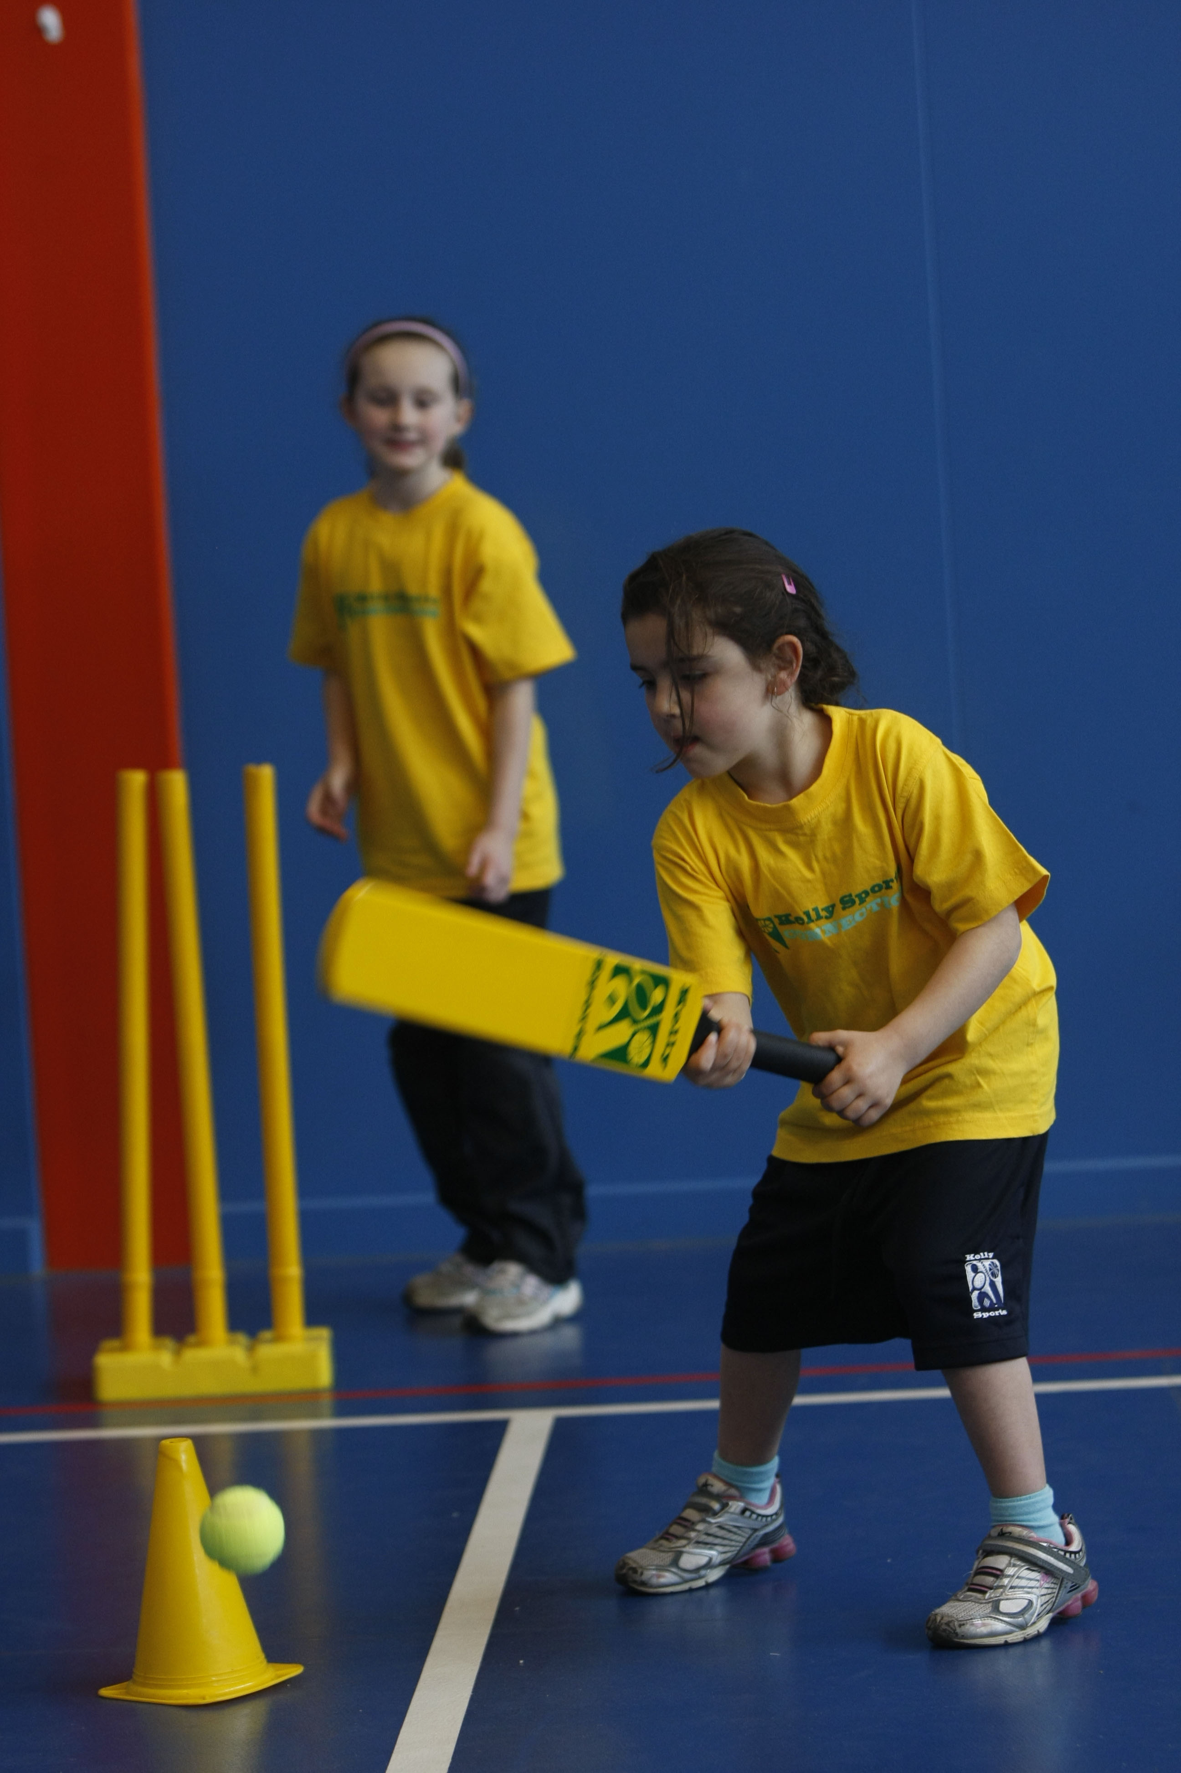

**FUNDAMENTAL**

**SKILLS PROGRAM**

Kelly Sports runs half hour programmes to teach children the fundamentals of sport. This 7 **WEEK** program is all inclusive with high participation. Our key aims are to develop and enhance the following skills – **running, jumping, catching, throwing, passing, kicking and striking:**

The Fundamental Skills Program includes:  
**- Motor Skill Development  
- Balance and Hand- Eye Cordination  
- Introduction to a variety of sports -Soccer, Basketball, Football.**

**WHEN: Tuesday**

**COMMENCING:** 13/01/2015

**CONCLUDING:** 24/02/2015

**TIME:**  1:30 pm. until 2.00 pm.



**COST: $45** (enrol online go to [**www.kellysports.com.a**](http://www.kellysports.com.a)**u** and search for your school/centre)

**It’s here online enrolments !**

**To enrol**, please visit [www.kellysports.com.au](http://www.kellysports.com.au) or

fill out the enrolment form & **send** with a cheque or credit card details to:

Kelly Sports PO BOX 71, Moonee Vale, VIC, 3055.

Payment options available!

Do **not** leave enrolment forms at the school office

**VENUE: Mother Goose Early Learning Centre**

**It’s here online enrolments !**

**To enrol**, please visit [www.kellysports.com.au](http://www.kellysports.com.au) or

fill out the enrolment form & **send** with a cheque or credit card details to:

Kelly Sports PO BOX 71, Moonee Vale, VIC, 3055.

Payment options available!

Do **not** leave enrolment forms at the school office

To enrol, please visit [**www.kellysports.com.au**](http://www.kellysports.com.au)and search for yourschool/centre or fill out the enrolment form below & sendwith a cheque or credit card details to: **PO BOX 3180 Joondalup W.A. 6027**. Payment options available.

**ONLINE ENROLMENT**

**www.kellysports.com.au**

**ENROLMENT FORM**

Childs Name:_____________________________________________________________________________ Year Level:

Parents Name:___________________________________________________________________________ Room No:

Address: Post Code:

Phone: Mobile/Work:

Email: Medical Conditions:

**Parents’ consent: I hereby authorise Kelly Sports to act on my behalf should my child require medical attention, and release   
Kelly Sports from any liability for injury incurred by my child at Kelly Sports programmes.**

Name On Card: Signature:

Amount Paid: $_________________________ Credit card payment: □ **Visa** □ **Mastercard CCV Number**  □□□

Card Number: □□□□ □□□□ □□□□ □□□□ Expiry Date: □□/□□

**It’s here online enrolments !**

**To enrol**, please visit [www.kellysports.com.au](http://www.kellysports.com.au) or

fill out the enrolment form & **send** with a cheque or credit card details to:

Kelly Sports PO BOX 71, Moonee Vale, VIC, 3055.

Payment options available!

Do **not** leave enrolment forms at the school office

**It’s here online enrolments !**

**To enrol**, please visit [www.kellysports.com.au](http://www.kellysports.com.au) or

fill out the enrolment form & **send** with a cheque or credit card details to:

Kelly Sports PO BOX 71, Moonee Vale, VIC, 3055.

Payment options available!

Do **not** leave enrolment forms at the school office

**It’s here online enrolments !**

**To enrol**, please visit [www.kellysports.com.au](http://www.kellysports.com.au) or

fill out the enrolment form & **send** with a cheque or credit card details to:

Kelly Sports PO BOX 71, Moonee Vale, VIC, 3055.

Payment options available!

Do **not** leave enrolment forms at the school office