
T 0466 501 822


E ann@kellysports.com.au

Kelly Sports Mornington Peninsula Region

LANGWARRIN PRIMARY SCHOOL
AWESOME AUTUMN SPORTS

Kelly Sports is back in Term 2 for AWESOME AUTUMN SPORTS!! Over 8 weeks your child will participate in a range of lively and energetic programs including AFL, SOCCER, BASKETBALL, HOCKEY. This program will not only improve key sporting skills but also increase crucial motor skills in a fun, friendly and exciting environment. Enrol them now and let Kelly Sports give them a Life Long Love of Sports.

It’s here online enrolments!
To enrol, please visit www.kellysports.com.au or
fill out the enrolment form & send with a cheque or credit card details to:
Kelly Sports PO BOX 71, Moonee Vale, VIC, 3055.
Payment options available!
Do not leave enrolment forms at the school office

It’s here online enrolments !
To enrol, please visit www.kellysports.com.au or
fill out the enrolment form & send with a cheque or credit card details to:
Kelly Sports PO BOX 71, Moonee Vale, VIC, 3055.
Payment options available!
Do not leave enrolment forms at the school office

WHEN: TUESDAYS
COMMENCING: 8/ 5/18
CONCLUDING: 26/6/18
TIME: 3.40pm – 4.40pm
YEAR LEVELS: P – GRADE 4
COST: $80

FEES MUST BE PAID BY WEEK 3

It’s here online enrolments!
To enrol, please visit www.kellysports.com.au or
fill out the enrolment form & send with a cheque or credit card details to:
Kelly Sports PO BOX 71, Moonee Vale, VIC, 3055.
Payment options available!
Do not leave enrolment forms at the school office

It’s here online enrolments!
To enrol, please visit www.kellysports.com.au or
fill out the enrolment form & send with a cheque or credit card details to:
Kelly Sports PO BOX 71, Moonee Vale, VIC, 3055.
Payment options available!
Do not leave enrolment forms at the school office

It’s here online enrolments!
To enrol, please visit www.kellysports.com.au or
fill out the enrolment form & send with a cheque or credit card details to:
Kelly Sports PO BOX 71, Moonee Vale, VIC, 3055.
Payment options available!
Do not leave enrolment forms at the school office

SIGN UP FAST FOR TERM 2
SPORTS

GET IN QUICK FOR TERM 2 AS PLACES ARE LIMITED AND WILL FILL FAST
$80 FOR THE 8 WEEK PROGRAM
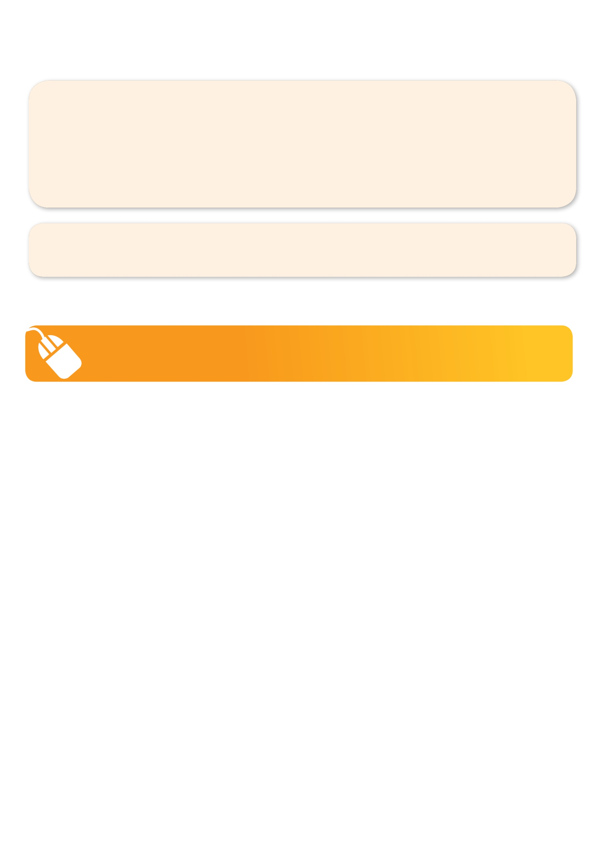
NEW IMPROVED ONLINE BOOKING SYSTEM!!!
SIMPLY GO TO WWW.KELLYSPORTS.COM.AU ENTER IN YOUR POSTCODE AND CLICK ON LANGWARRIN PRIMARY SCHOOL’S PROGRAM

KELLY SPORTS ALSO DOES SCHOOL HOLIDAY PROGRAMS & BIRTHDAY PARTIES.
Like our Facebook page, Kelly Sports Mornington Peninsula Region to keep up to date with what is happening in your area.

